Fluorescence Microscope

Operation manual
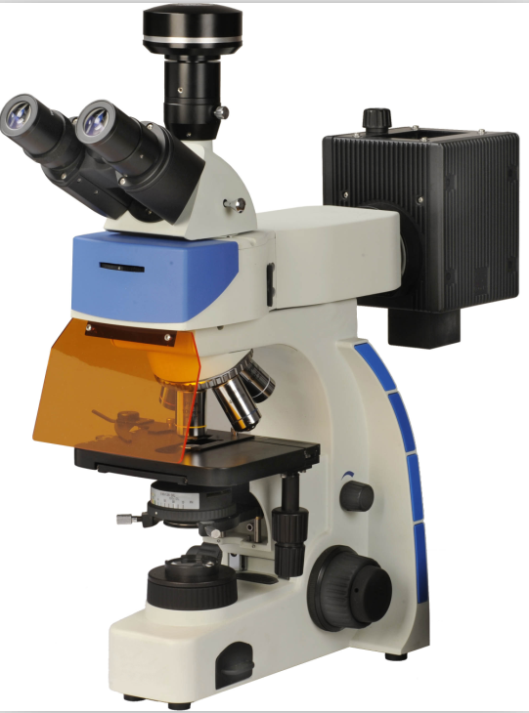

This operation manual is for the Fluorescence Microscope. A thorough and careful reading of the manual is advised for safe and easy use of the microscope.

Contents
Correct assembly and adjustments are critical for the microscope to exhibit its full performance. If you are going to assemble the microscope yourself, please read Chapter2, “ASSEMBLY” (pages6-8) carefully. For the modules provided with instruction manuals, also read the assembly procedures in their instruction manuals.

IMPORTAT
Be sure to read this section for safe use of the equipment...1-3
1 SAFETY SYMBOLS ON THE MICROSCOPE......................................................... 1
2 Caution Symbols in this Manual............................................................................... 1
3 Safety Precautions ................................................................................................... 1
4 Moving the Microscope............................................................................................. 2
5 Working environment............................................................................ ................... 3
6 Electric Power Specifications................................................................................... 3
7 Maintenance and Storage........................................................................................ 3
8 Unpacking the Microscope....................................................................................... 3

1 MODULE & CONTROLS NOMENCLATRUE.......................... 4-5
2 ASSEMBLY............................................................................. 6-8
2.1 Assembly Diagram................................................................................................ 6
2.2 Detailed Assembly Procedures ............................................................................ 6
2.2.1 Attaching/Replacing the Bulb............................................................................. 6
2.2.2 Attaching the Observation Tube......................................................................... 7
2.2.3 Attaching the Eyepieces..................................................................................... 7
2.2.4 Attaching the Objectives .................................................................................... 7
2.2.5 Attaching the Condenser.................................................................................... 8
2.2.6 Mounting the Filter.............................................................................................. 8

3 LIGHT BRIGHTFIELD OBSERVATION................................ 9-13
3.1 Light Bright field Observation Procedure............................................................... 9
3.2 Using the Controls............................................................................................... 10
3.2.1 Power Supply Unit............................................................................................ 10
3.2.2 Focusing Block................................................................................................. 10
a) Rotation Direction of the Coarse/Fine Adjustment Knobs.................................... 10
b) Adjusting the Coarse Adjustment Knob Tension.................................................. 10
3.2.3 Mechanical Stage............................................................................................. 10
a) Placing the Specimen on the stage...................................................................... 10
b) Moving the Specimen........................................................................................... 10
c) Raise and lower the stage.................................................................................... 10
3.2.4 Observation Tube............................................................................................ 10
a) Adjusting the Interpupillary Distance.................................................................... 10
b) Adjusting the Diopter............................................................................................ 11
c) Using the Eye Shades.......................................................................................... 11
3.2.5 Condenser........................................................................................................ 11
a) Centering the Condenser...................................................................................... 11
b) Using the Aperture Iris Diaphragm........................................................................ 12
c) Condenser height adjustment................................................................................ 12
3.2.6 Objectives......................................................................................................... 12
a) Engage the Required Objectives........................................................................... 12
b) Using Immersion Objectives.................................................................................. 12
3.2.7 Filters................................................................................................................ 13

4 OTHER OBSERVATION METHODS.................................. 14-15
4.1 Phase Contrast Observation................................................................................ 14
4.2 Simplified Polarized Light Observation................................................................ 14
4.3 Dark Field Light Observation.................................. .............................................15
4.4 CCD & Computer Observation............................................................................ 15
4.5 Digital Camera Observation................................................................................ 15
4.6 Camera................................................................................................................ 15

5 TROUBLESHOOTING GUIDE............................................ 16-18

6 STANDARD OUTFITS & SPECIFICATIONS..................... 19-22

IMOPRTANT
1 SAFETY SYMBOLS ON THE MICROSCOPE
The following symbols are found on the microscope. Study the meaning of the symbols and always use the equipment in the safest possible manner.
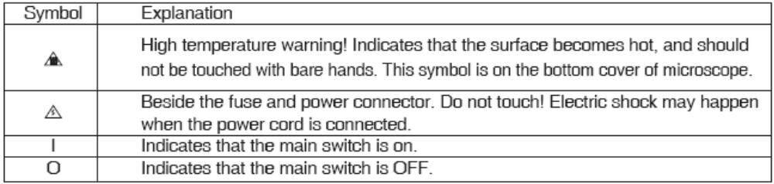

2 Caution Symbols in this Manual
If the microscope is used in a manner not specified by this manual, the safety of the user may be imperiled. In addition, the equipment may also be damaged. Always use the equipment as outlined in this instruction manual. The following symbols are used to set off text in this instruction manual.
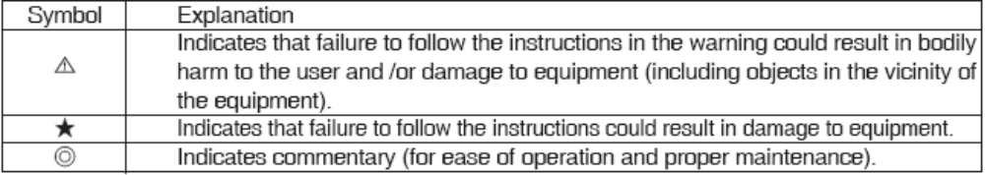

3 Safety Precautions
3.1 After the equipment has been used in an observation of a specimen that is accompanied with a potential of infection, clean the parts coming in contact with the specimen to prevent infection.
· Moving this product is accompanied with the risk of dropping the specimen. Be sure to remove the specimen before moving this product.
· In case the specimen is damaged by erroneous, promptly take the infection prevention measures.
3.2 The microscope is provided with a simplified waterproof mechanism. Therefore, if culture liquid or water is split on the stage, revolving nosepiece or microscope frame, damage to the equipment or an electrical shock may result. Immediately wipe the liquid or water off if it is spilt on them.
3.3 The microscope is not covered by warranty in terms of laser safety. The user should assume liabilities for any consequence of user modification,
3.4 The surfaces of the lamp housing will become extremely hot during long-time operation. Be sure to keep the flammable stuffs such as paper, alcohol, oil away from the lamp house to avoid fire.
3.5 When using the microscope, route the power cord away from the lamp housing. Should the power cord come in contact with the hot lamp housing, the power cord could melt and cause electric shock.
3.6 To avoid potential shock hazards and burns when replacing the light bulb, set the main Switch to “O” (OFF) then disconnect the power cord from the wall outlet in advance. Whenever you replace the bulb during use or right after use, allow the lamp housing and bulb to cool before touching.
3.7 Electric shock warning:
Remove of the bottom cover of the microscope makes the dangerous electric parts inside exposed. Any contact with these parts may cause shock or death. In event of maintenance, please apply to qualified professionals for help.
3.8 The G4 bulb socket is designed specially for 6V/20W halogen bulb. Damage will occur if bulb of different description is replaced.
3.9 Always be sure the power cord provided by ourselves. If the proper power cord is not used, product safety performance cannot be warranted.
3.10 To avoid potential shock hazards when replacing the fuse, set the main switch to “O” (OFF) then disconnect the power cord from the wall outlet in advance.
3.11 Always ensure that the grounding terminal of the microscope and that of the wall outlet are properly connected. If the equipment is not grounded, we can no longer warrant the electrical safety performance of the equipment.
3.12 Never insert metallic objects into the air vents(A⑨ in Fig.2) of the microscope frame as this could result in electrical shock, personal injury and equipment damage.
3.13 A microscope is a precision instrument. Handle it with care and avoid subjecting it to sudden or severe impact.
4 Moving the Microscope
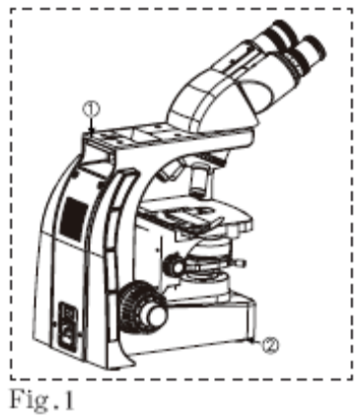
4.1 When moving the microscope, remove the observation tube, then carefully carry the microscope frame by the base (front edge)(② in Fig.1) and the grasping part(①in Fig.1) in the upper rear.
4.2 Also be sure to remove the specimen since it may fall.
4.3 When moving the microscope for a long distance, it is also recommended to disconnect all cables from the equipment.
4.4 When transporting it, also engage the adhesive tape lock mechanisms and package it sufficiently.
4.5 Also be careful against slipping of hands during carrying.
★ Damage to the microscope will occur if you grasp it by other parts including the stage, coarse/fine adjustment knobs, the nosepieces, etc.
5◎Working environment
5.1 Indoor use.
5.2 Ambient Temperature: 5℃to 40℃ (41℉to 104℉)
5.3 Maximum relative humidity: 80% for temperatures up to 31℃ (93℉), 60% at 37℃(99℉),to 50% relative humidity at 40℃ (104℉).
5.4 Supply voltage fluctuations: ±10%
5.5 Pollution degree: 2 (In accordance with IEC60664)
6 Electric Power Specifications
Input: 100-240V～0.5A, 47-63Hz
Output:6V 3.4A
Fuse:3.15A, 250V, F ф5×20mm
Halogen Bulb Socket: G4
7◎Maintenance and Storage
7.1 Clean all glass components by wiping gently with gauze. To remove fingerprints of oil smudges, wipe with gauze slightly moistened with a mixture of ether (70%) and alcohol (30%).Since solvents such as ether and alcohol are highly flammable, they must be handled carefully. Be sure to keep these chemicals always from open flames, or potential sources of electrical sparks—for example, electrical equipment that is being switched on or off. Also remember to always use these chemicals only in a well-ventilated room.
7.2 Be sure to clean the oil immersion objective after use. Leaving immersion oil on it will degrade its performance.
7.3 Do not attempt to use organic solvents to clean the non-optical components of microscope. To clean them, use a lint-free, soft cloth slightly moistened with a diluted neutral detergent.
7.4 Never attempt to disassemble any part of the microscope.
7.5 When not using the microscope, make sure to set the main switch to “O” (OFF), confirm that the lamp housing is cool enough and cover the microscope with the provided dust cover.
7.6 Do not use the microscope where it is subjected to direct sunlight, high temperature and humidity, dust or vibrations.
8 UNPACKING THE MICROSCOPE
8.1 Please check all the components according to the packing list in the package as you unpacking the microscope. Contact us or our distributor as soon as possible if any component is missed in the package.
8.2 Before transporting the microscope, we have fixed the flexible parts of the stage with pieces of adhesive tape, please remove the adhesive tapes before use.

1.MODULES & CONTROLS NOMENCLATURE
◎ The modules shown below are only the representative modules. As there are other modules which can be combined with the microscope but are not shown below. Please also refer to the latest catalogues or your dealer.
◎ If you have not yet assembled the microscope, read Chapter 2, “Assembly” (pages6-8)
● The illustration shows the system composed of modules and controls enclosed in □.

RIGHT SIDE VIEW OF MICROSCOPE
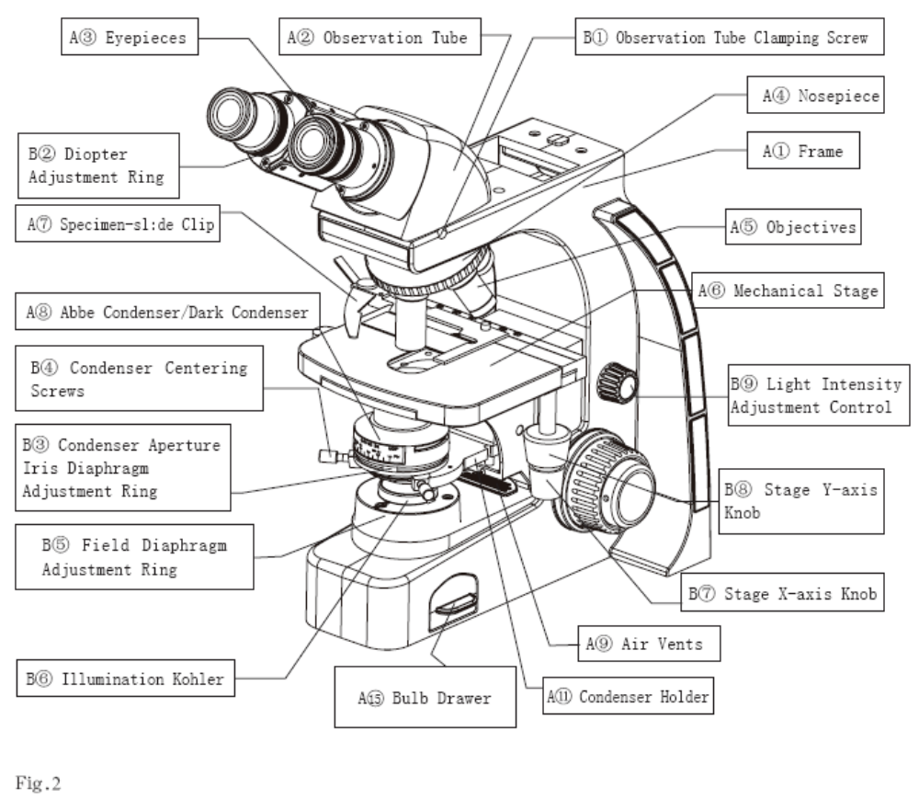

LEFT SIDE VIEW OF MICROSCOPE
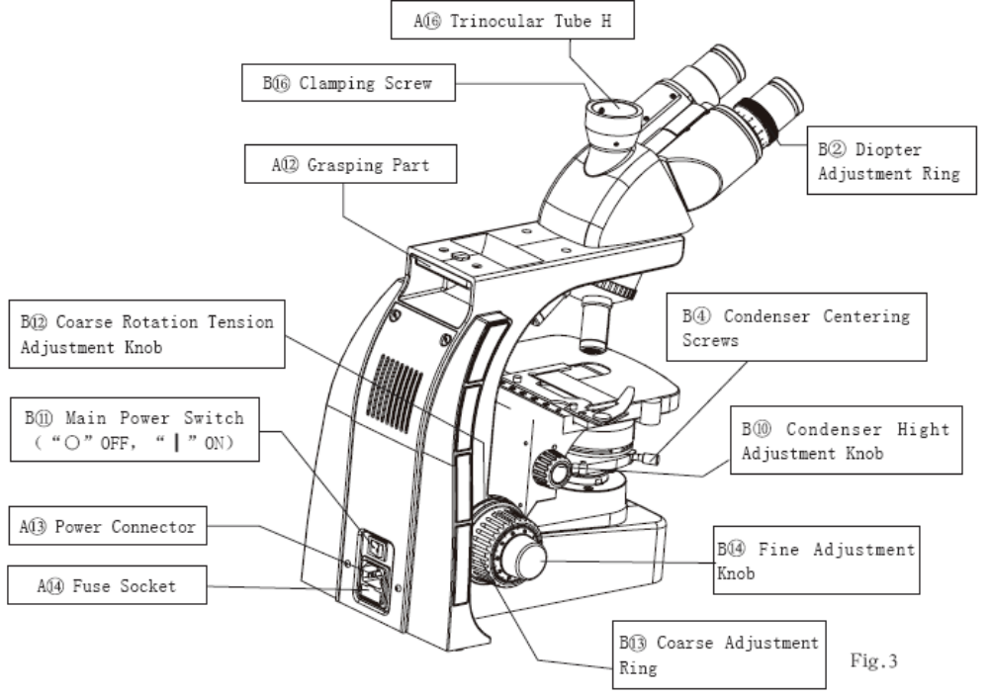

A1 Frame A2 Observation Tube A3 Eyepieces
A4 Nosepiece A5 Objectives A6 Mechanical Stage
A7 Specimen-slide Clip A8 Abbe Condenser/Dark Condenser A9 Air Vents
A10 Filter Holders(Figs.6&7) A11 Condenser Holder A12 Grasping Part
A13 Power Connector A14 Fuse Socket A15 Bulb Drawer(Fig.5)
A16 Trinocular Tube H
B1 Observation Tube Clamping Screw B2 Diopter Adjustment Ring
B3 Condenser Aperture Iris Diaphragm Adjustment Ring B4 Condenser Centering Screws(two)
B5 Field Diaphragm Adjustment Ring B6 Illumination Kohler
B7 Stage X-axis Knob B8 Stage Y-axis Knob
B9 Light Intensity Adjustment Control B10 Condenser height Adjustment Knob
B11 Main Power Switch（“○”OFF，“┃”ON） B12 Coarse Rotation Tension Adjustment Ring
B13 Coarse Adjustment Knob B14 Fine Adjustment Knob
B15 Grip of the Bulb Drawer B16 Clamping Screw

2. ASSEMBLY
2.1 Assembly Diagram
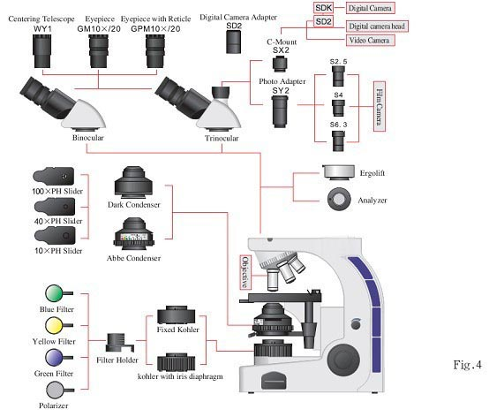

2.2 Detailed Assembly Procedures
2.2.1 Attaching/Replacing the Halogen Bulb( ② in Fig.5)
Caution for Bulb Replacement During or Right After Use.
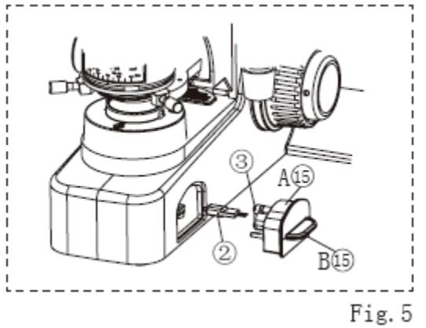
To avoid potential shock hazards and burns when replacing the light bulb, set the main switch (B in Fig.3) to “O” (OFF) . Then disconnect the power cord from the wall outlet in advance. Whenever you replace the bulb during use or right after use, allow the lamp housing and bulb to cool before touching.
To prevent reduced bulb life or cracking, do not touch the bulb with bare hands. If finger prints are accidentally left on the bulb, wipe the bulb with a soft cloth.
a) Grip the Grip (B15 in Fig.5) of the bulb drawer and pull out the bulb drawer (on the right side of the microscope base, A15 in Fig.5).
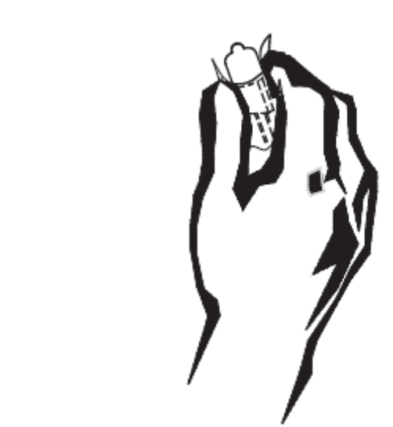
b) Pull out the burnt-out bulb from the bulb socket if you want to replace it.
d) Hold the new bulb with gloves or a piece of gauze, insert the bulb pins and fully into the pin sections on(③in Fig.5) the bulb socket.
e) Push in the bulb drawer and close the lamp house.
◎ After working for above 10 hours, cut off the instrument about 30 minutes to prolong the bulb life as possible.

2.2.2 Attaching the Observation Tube (Figs.2&4 )
a) Using the Allen screwdriver, loosen the observation tube clamping screw (B① in Fig.2)on the observation tube mount.
b) Attach the circular dovetail mount of the observation tube into the observation tube mount , placing the observation tube so that the interpupillary distance scale numbers are seen right side up. Then tighten the clamping screw to clamp the observation tube.
2.2.3 Attaching the Eyepieces (Figs.2&4)
a) Remove the eyepieces’ dust caps.
b) Insert the eyepiece into the eyepiece sleeve.
2.2.4 Attaching the Objectives (Fig.2)
Be sure no specimen is on the stage before you attaching the objectives to prevent potential damage to the specimen-slide.
a) Lower the stage to the farthest position.
b) Screw the objectives into the nosepiece(A④ in Fig.2) in the order from lower-power to higher-power.
c) Please cover the empty positions in the nosepiece with the dust cap to protect the
optical parts form the dust.
2.2.5 Attaching the Condenser (Figs.2&4)
a) Raise the stage to the farthest position by rotating the coarse adjustment knob (B13 in Fig.3) and lower the condenser holder to the farthest position by rotating the
condenser height adjustment knob(B⑩ in Fig.3)
b) Loosen the condenser centering screws. (B④ in Fig.2)
c) Fit the required condenser into the mount dovetail on the condenser holder (A11 in Fig.2), and push in the condenser until its positioning pin fits into the positioning groove on the mount dovetail of the condenser holder.
d) Tighten the condenser centering screws.
e) Centering the condenser. (See page11, 3.2.5.a)
2.2.6 Mounting the Filter (Figs. 4、6&7)
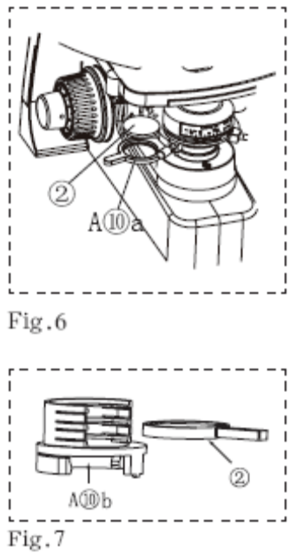
a) Movable filter holder (attached to the bottom of condenser holder) and filter holder (attached to the illumination Koehler) are both available for UB100i series microscope.
b) Mount the filter to the movable filter holder (Fig.6)
b.1 Stir the filter holder (A⑩a in Fig.6)out to the left from the bottom of the condenser holder(A11 in Fig.2)
b.2 Insert the filter(② in Fig.6) down into the filter holder without tilting. Move the holder(A⑩a in Fig.6) back to the position right down the condenser into the light path.
c) Mount the filter to the filter holder. (Fig.7)
c.1 Push the filter holder(A⑩b in Fig.7)downwards and mount it to the illumination Kohler. (B⑥ in Fig.2)
c.2 Insert the required filter (② in Fig.7) into the holder. More than one filter can be stacked in this filter holder.

3. LIGHT BRIGHTFIELD OBSERVATION PROCEDURE
3.1 LIGHT BRIGHTFFIELD OBSERVATION PROCEDURE
◎ The following flow shows the operating procedure for the transmitted light bright field observation which is the basic observation method of this microscope. The operating procedures for phase contrast observation, dark field and Polarization observation will be described separately in Chapter5, “OTHER OBSERVATION METHODS”(Pages 14-15)
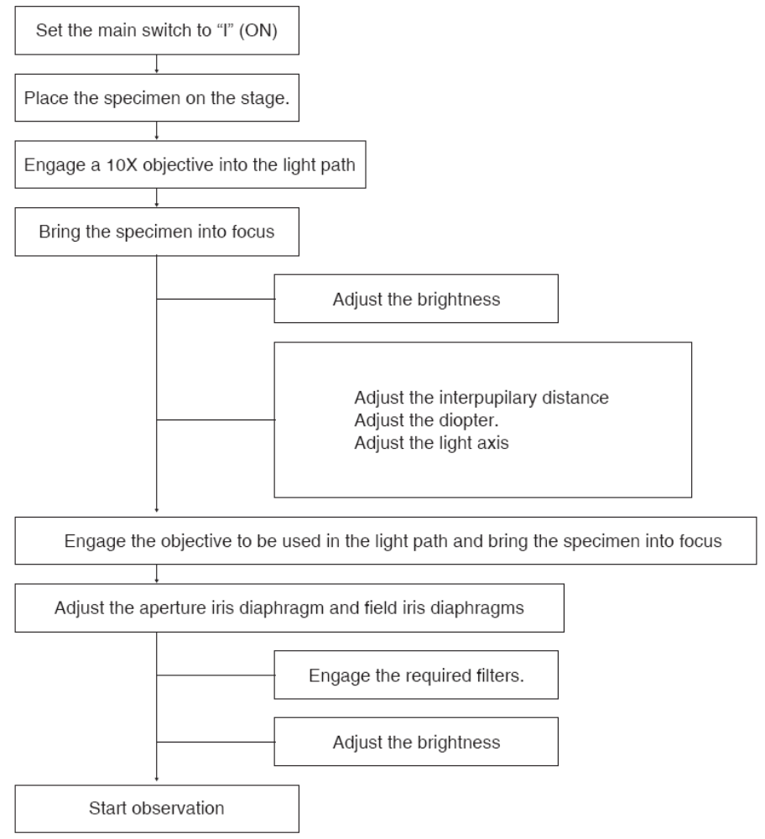
3.2 USING THE CONTROLS
3.2.1 Turning Power On, Adjusting the Brightness(Figs.2&3)
a) Make sure that the light intensity control (B⑨ in Fig.2)is in the MIN (minimum intensity) position and set the main switch(B Fig.3) to “I” (ON).
b) Rotate the Light intensity control toward MAX (maximum intensity) to increase the intensity and the illumination brightness.
3.2.2 Focusing Block(Figs.3&8)
a) Rotation Direction of the Coarse/Fine Adjustment Knobs
◎ Rotating the coarse or fine focus adjustment knob(B ,B in Fig.8) toward the front lowers the stage and toward the rear raises the stage.
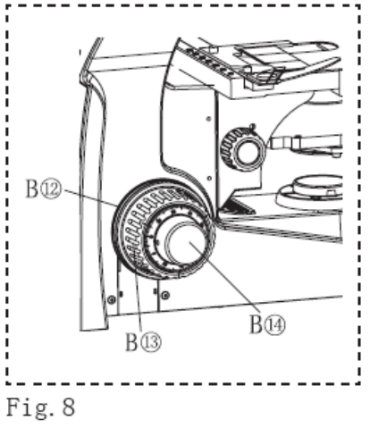
★ Never rotating the right and left coarse adjustment knobs reversely at the same time, this will damage the focusing block.
b) Adjusting the Coarse Adjustment Knob Tension(Fig.8)
★ Always use the rotation tension adjustment ring(B in Fig.8) to control the rotation tension of the coarse adjustment knob. The tension of the coarse adjustment knob has been pre-adjusted to optimum tension, but this can be changed as required. Turn the rotation tension adjustment ring toward the rear to increase or toward the front to decrease the knob’s tension. If the stage lowers by its own weight or the focusing obtained with the fine adjustment knob is lost soon, the tension is set too low. In this case, turn the rotation tension adjustment ring toward the rear to increase the tension.
3.2.3 Mechanical Stage (Figs.2, 9&10)
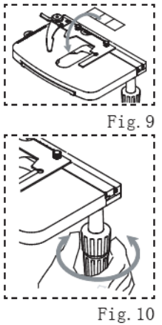
a) Placing the Specimen on the stage. Place the specimen on the center of the stage. Attach the stage clips and clamp the specimen
b) Moving the Specimen To move the specimen to a desired position, rotate the X-axis knob and Y-axis knob to move the stage. The travel area is 76mm(X-axis) x 52mm(Y-axis).
c) Raise and lower the stage.(Ref:page10, 3.2.2.a )
3.2.4 Observation Tube (Figs.2, 11&12)
a) Adjusting the interpupillary Distance (Fig.11) While looking through the eyepieces, adjust the binocular vision until the left and right fields of view coincide completely.
◎ The interpupillary Distance of is 52-74mm.
b) Adjusting the Diopter. (Fig.12)
◎ The diopter adjustment accuracy can be improved by using an objective with as high power as possible.
b.1 While looking through the right eyepiece, rotate the coarse/fine adjustment knobs to bring the specimen into focus.
b.2 Look through the left eyepiece and rotate only the diopter adjustment ring(B② in Fig.2) on the left eyepiece sleeve to bring the specimen into focus.
★ When rotating the diopter adjustment ring of the left eyepiece, hold the lower part of the left eyepiece with the other hand.
c) Using the eye Shades
c.1 When Wearing eyeglasses Use with the eyeshades in the normal, folded-down position. This will prevent the eyeglasses from being scratched.
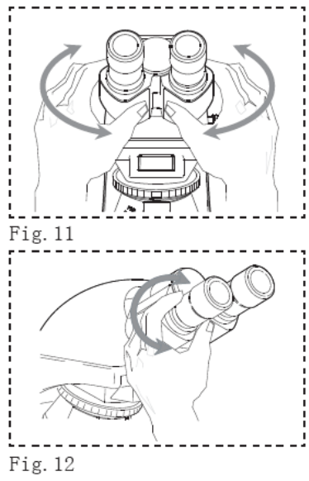
c.2 When Not Wearing Eyeglasses Extend the folded eye shades in the upward direction to prevent extraneous light from entering between the eyepieces and eyes.
3.2.5 Condenser (Numerical aperture (N.A.) 1.25 oil)
a) Centering the Condenser (Figs.2, 13,14&15)
◎ Your microscope illumination Kohler is with field diaphragm or without field diaphragm as you required. The center of condenser had bee accurately centered.
a.1 If you have to re-center the condenser when the microscope illumination Kohler is with field diaphragm (Fig.13)
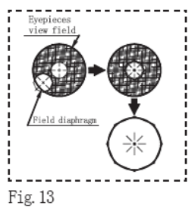
① Slide the field diaphragm adjustment ring(B⑤ in Fig.2) to the left to open the diaphragm.
② Slide the field iris diaphragm ring to the fully open position.
③ Engage the 10X objective and bring the specimen into focus.
④ Using the field iris diaphragm ring, stop down the field iris diaphragm until its image is just inside the field of view.
⑤ Rotate the condenser height adjustment knob to bring the field iris diaphragm image into focus.
⑥ While gradually opening the field iris diaphragm, rotate the condenser centering Screws(B④ in Fig.2) on the condenser holder to adjust so that the field iris diaphragm image is centered in the field of view of the eyepieces.
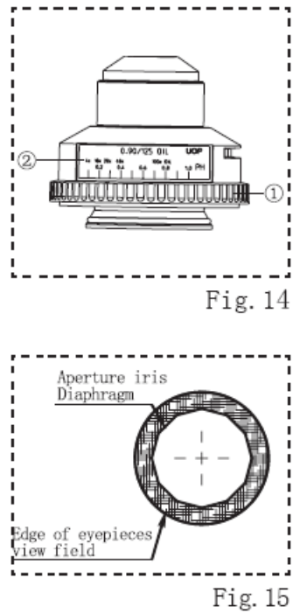
⑦ To check centre, open the field iris diaphragm until its image inscribed the field of view. Now the condenser is centered.
◎ In actual observation, open the field iris diaphragm until its image circumscribed the field of view.
a.2 If you have to re-center the condenser when the microscope illumination Kohler is without field diaphragm,
① Stop down the condenser aperture iris diaphragm to correspond with a 10x objective.
② Engage a 10x objective into the light path and bring the specimen into focus.
③ Rotate the condenser centering screws on the condenser holder to adjust so that the specimen image is flat, evenly bright, and full in the field of view of the 10x eyepiece.
④ Now the condenser is centered.
b) Using the Aperture Iris Diaphragm( Fig.14&15)
◎ In general, the potential resolving power of an objective is fully utilized if the diaphragm is stopped down to correspond with the numerical aperture (N.A.) of the objective.
◎ Depending on the specimen, image contras of focal depth in observation or photomicrography may be improved by keeping the aperture iris diaphragm stopped down a little. In general, a good image is obtained if the diaphragm is stopped down to between 70% and 80% of the N.A. of the objective. Stop further down for less contrast specimens.
◎ To check the position of the perimeter of the aperture iris diaphragm, remove the eyepieces and look into the eyepiece sleeves to view the aperture iris diaphragm image and the objective’s exit pupil. Slide the field iris diaphragm ring(① in Fig.14) to the right to open the diaphragm, and slide the aperture iris diaphragm ring to the left to shut the diaphragm.
◎ There is color coded mark(② in Fig.14) on the condenser. The magnification of the objectives, the PH objective, the N.A. of the condenser is cleared coded with different color in the mark. For different objective observation, the white line on the iris stop at the corresponding position can bring you best observation.
c) Condenser Height Adjustment: Rotate the condenser height adjustment knob(B⑩ in Fig.3) toward the front to lower the condenser, toward the rear to raise the condenser. Adjust the height of the condenser and to bring the field diaphragm image into focus.
3.2.6 Objectives
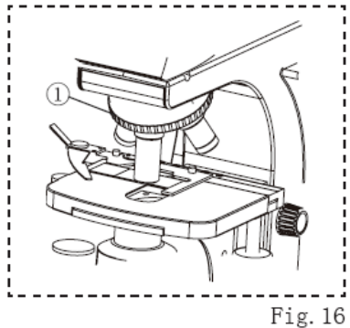
a) Rotate the revolving nosepiece by its rim(① in Fig.16) to engage the required objective into the light path and stop at the “click” position.
b). Do not rotate the nosepiece by pushing the objectives (A⑤ in Fig.2), this will damage the positioning accuracy of the objectives.
c) Using 100X Immersion objectives (Fig.17)
c.1 Using a 40X objective, bring the specimen into focus.
c.2 Rotate the revolving nosepiece counterclockwise, stop down in the position where the specimen is just between the 40X objective and 100X objective.
c.3 Apply a drop of the provided immersion oil to the specimen cover, then rotate the revolving nosepiece to engage the oil immersion objective into the light path.
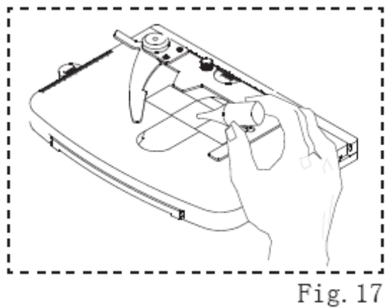
★ Please remove the oil immediately after use.
★ If the oil contains air bubbles, the image will be degraded. Make sure the oil is free of air bubbles. To remove air bubbles, slightly rock the revolving nosepiece manually to engage and disengage the oil immersion objective once or twice. After use, wipe away the immersion oil at the objective front lens and the specimen with a piece of gauze lightly moistened with a mixture of ether (70%) and alcohol(30%) Caution on using the immersion oil:
If immersion oil comes into contact with your eye or skin, immediately take the following action.
For eye: Rinse with clean water (for more than 15 minutes),
For skin: Wash with soap and water.
If the appearance of the eye or skin changes or pain continues, immediately consult
your doctor.
3.2.7 Filters
a) Filters of different colors are required according to different tinct specimens.
b) If there is no needs of the filter or requiring to enhance the light intensity in the view
field while the plan achromatic objective 100×(oil) is being employed, stir the movable
filter holder towards the left side out from the light path.

4. OTHER OBSERVATION METHODS
4.1 Phase Contrast Observation (Fig.18)
4.1.1 Phase Contrast Optical Elements and Applicable Objectives
Optical Element Applicable Objectives
10X Phase slide 10X/0.30 PH
40X Phase slide 40X/0.70 PH
100X Phase slide 100X/1.25(oil) PH
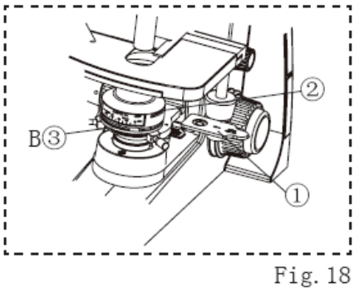
4.1.2 Phase Contrast Observation
a) Conduct the preparation according to the bright field observation procedure.
b) Slide the aperture iris diaphragm ring(B③ in Fig.18) toward far right to the PH position.
c) Rotate the revolving nosepiece and engage the applied PH objective into the light path.
d) Slowly slide the corresponding Phase slide(① in Fig.18) into the socket(② in Fig.18) on the right side of the condenser (be sure the side of the slide with marks facing upside).
e) Then you are ready to start your phase contrast observation.
4.2 Simplified Polarized Light Observation (Fig.19,20&24)
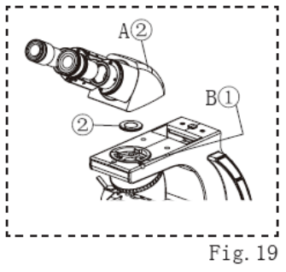
◎ An analyzer and polarizer are required for simplified polarized light observation.
4.2.1 Attaching the Analyzer and Polarizer.
a) Using the Allen screwdriver, loosen the observation tube clamping screws(B① in Fig.19) on the observation tube mount and remove the observation tube(A② in Fig.19).
b) Hold the polarizer(② in Fig.19), insert the polarizer positioning pin fully into the pin section of the observation tube mount. Be sure the polarizer is tightly and evenly placed in the observation tube mount.
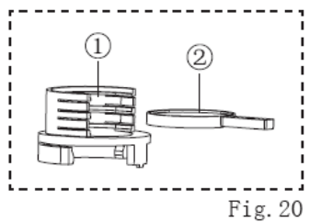
c) Reassembly the observation tube. (Ref:page 7,2.2.2)
d) Mount the filter holder(① in Fig.20) to the
illumination Kohler.
e) Insert the analyzer(② in Fig.20) into the filter holder
with the symbol side upward.
4.2.2 Polarized light observation:
a) Before your polarized light observation, do your preparation as the bright light observation.
b) Rotate the analyzer and stop in the position when your eyepieces view field is of the darkest.
c) Place the required specimen on the stage and start your polarize light observation.
4.3 Dark-Field Light observation
4.3.1 Conduct the preparation according to the bright field observation procedure.
4.3.2 Attach the dark condenser into the condenser holder the same way as Abbe condenser.(Ref, Page 8, 2.2.5)
4.3.3 Start your dark field observation.
4.4 Digital Camera Head and Computer Observation (Fig.4)
4.4.1 Firmly screw the C-mount (SX2) into the digital camera head.
4.4.2 Loosen the clamping screw (B in Fig.3) on the trinocular observation tube H(A in Fig.3).
4.4.3 Fit the C-mount (SX2) into the Trinocular observation tube H and tighten the clamping screw.
4.4.4 Connect the digital camera head and the computer by USB cord.
4.5 Digital Camera Photography (Fig.4)
4.5.1 Firmly screw the Digital-Camera-Adapter (SD2+SDK) tightly.
4.5.2 Connect the digital camera with the SDK, and then connect SD2 with SX2.
4.5.3 Loosen the clamping screw(B in Fig.3) on the trinocular observation tube H(A in Fig.3).
4.5.4 Fit the SX2 into the trinocular observation tube H and tighten the clamping screw.
4.6 Film Camera Photography (Fig.4)
4.6.1 Screw opens the Photo-Adapter (SY2).
4.6.2 Insert the required photo eyepiece into SY2 and screw close the SY2 tightly.
4.6.3 Connect the camera with SY2.
4.6.4 Loosen the clamping screw (B in Fig.3) on the trinocular observation tube H(A in Fig.3).
4.6.5 Fit SY2 into the trinocular observation tube H and tighten the clamping screw.

5. TROUBLESHOOTING GUIDE
Under certain conditions, performance of the microscope my be adversely affected by factors other than defects. If problems occur, please review the following list and take remedial action as needed.
If you cannot solve the problem after checking the entire list, please contact your local representative for assistance.

Problem | Causes | Remedy
1) The bulb does not light. | Power cord of the power supply unit is unplugged. | Plug in the power cord into a power outlet.
1) The bulb does not light. | Main switch of the power supply unit is not ON. | Set the main switch to “I” (ON).
1) The bulb does not light. | The fuse is burnt out | Replace the fuse.
1) The bulb does not light. | The bulb is burnt out. | Replace the bulb.
2) The bulb lights but the field of view is dark. | The voltage is too low | Increase light intensity to an optimum voltage.
2) The bulb lights but the field of view is dark. | Condenser is not well positioned. | Adjust the condenser height until the field iris diaphragm image is formed in the specimen plane.
2) The bulb lights but the field of view is dark. | Condenser is not centered. | Center the condenser so that the field iris diaphragm image is centered in the field of view.
2) The bulb lights but the field of view is dark. | Revolving nosepiece is not in a click position. | Make sure that the revolving nosepiece clicks properly into place.
2) The bulb lights but the field of view is dark. | Field iris diaphragm is not opened wide enough. | Open the field iris diaphragm sufficiently.
2) The bulb lights but the field of view is dark. | Too many filters are used. | Reduce the number of filters to the minimum  required.
3) Field of view is obscured or not Evenly illuminated. | The objective that falls outside the condenser’s illumination range is used. | Use a condenser that matches the objective.
3) Field of view is obscured or not Evenly illuminated. | Field iris diaphragm is not properly centered. | Center the field iris diaphragm correctly.
3) Field of view is obscured or not Evenly illuminated. | Field iris diaphragm is stopped down too far. | Open the field iris diaphragm sufficiently.
3) Field of view is obscured or not Evenly illuminated. | Revolving nosepiece is in an intermediate position | Engage the revolving nosepiece at a click  stop.
3) Field of view is obscured or not Evenly illuminated. | A filter is stopped in an intermediate position. | Set the filter at the appropriate position.
3) Field of view is obscured or not Evenly illuminated. | The frost filter is not engaged. | Engage the frost filter.
4) Dirt or dust is  visible in the field of  view. | Dirt/dust on the specimen. | Clean thoroughly.
4) Dirt or dust is  visible in the field of  view. | Dirt/dust on the eyepieces. | Clean thoroughly.
4) Dirt or dust is  visible in the field of  view. | Dirt/dust on a mirror unit. | Clean thoroughly.
4) Dirt or dust is  visible in the field of  view. | Dirt/dust on the optical  element. | Clean thoroughly.
4) Dirt or dust is  visible in the field of  view. | Condenser is not correctly positioned and the frosted filter or filter is focused. | Adjust the condenser height until the field iris  diaphragm image is formed in the specimen  plane.
5)Image glares | Condenser is raised too high. | Lower to the proper position.
5)Image glares | Aperture iris diaphragm is stopped down too far. | Open the aperture iris diaphragm.
6)Visibility of observe image is poor， Image is not sharp， Contrast is poor, Details are poorly visible. | Objective in use is not designed for UCIS series. | Replace with an objective designed for UCIS optics.
 | Front lens of the objective is dirty | Clean the objective.
 | Immersion oil is not being used with an oil immersion objective. | Use immersion oil.
 | Inappropriate slide or cover glass thickness. | Replace with glass of appropriate thickness.
 | Dirt/dust on glass components (condenser, objective, eyepieces, ) | Clean thoroughly.
 | Phase plate are not centered. | Center it.
7) Image is blurred. | Objective is engaged incorrectly in the light path. | Make sure that revolving nosepiece clicks into place correctly.
7) Image is blurred. | Specimen is tilted with respect to the stage. | Place the specimen correctly on the stage.
8) Field of view of one eye does not match that of the other. | The interpupillary distance is incorrect. | Adjust the interpupillary distance.
 | Incorrect diopter adjustment. | Adjust the diopter.
 | You are not accustomed to parallel optical axis. | When looking into eyepieces, do not stare at image from the beginning but see the overall field of view. It is sometimes recommended to turn your eyes away from the eyepieces, look far off and look in to the eyepieces again.
9)The coarse/fine adjustment knobs will not rotate easily or at all. | The rotation tension adjustment ring is too tight. | Loosen the ring optimally.
10) The stage lowers by its own weight. | The rotation tension adjustment ring is too loose. | Tighten the ring optimally.

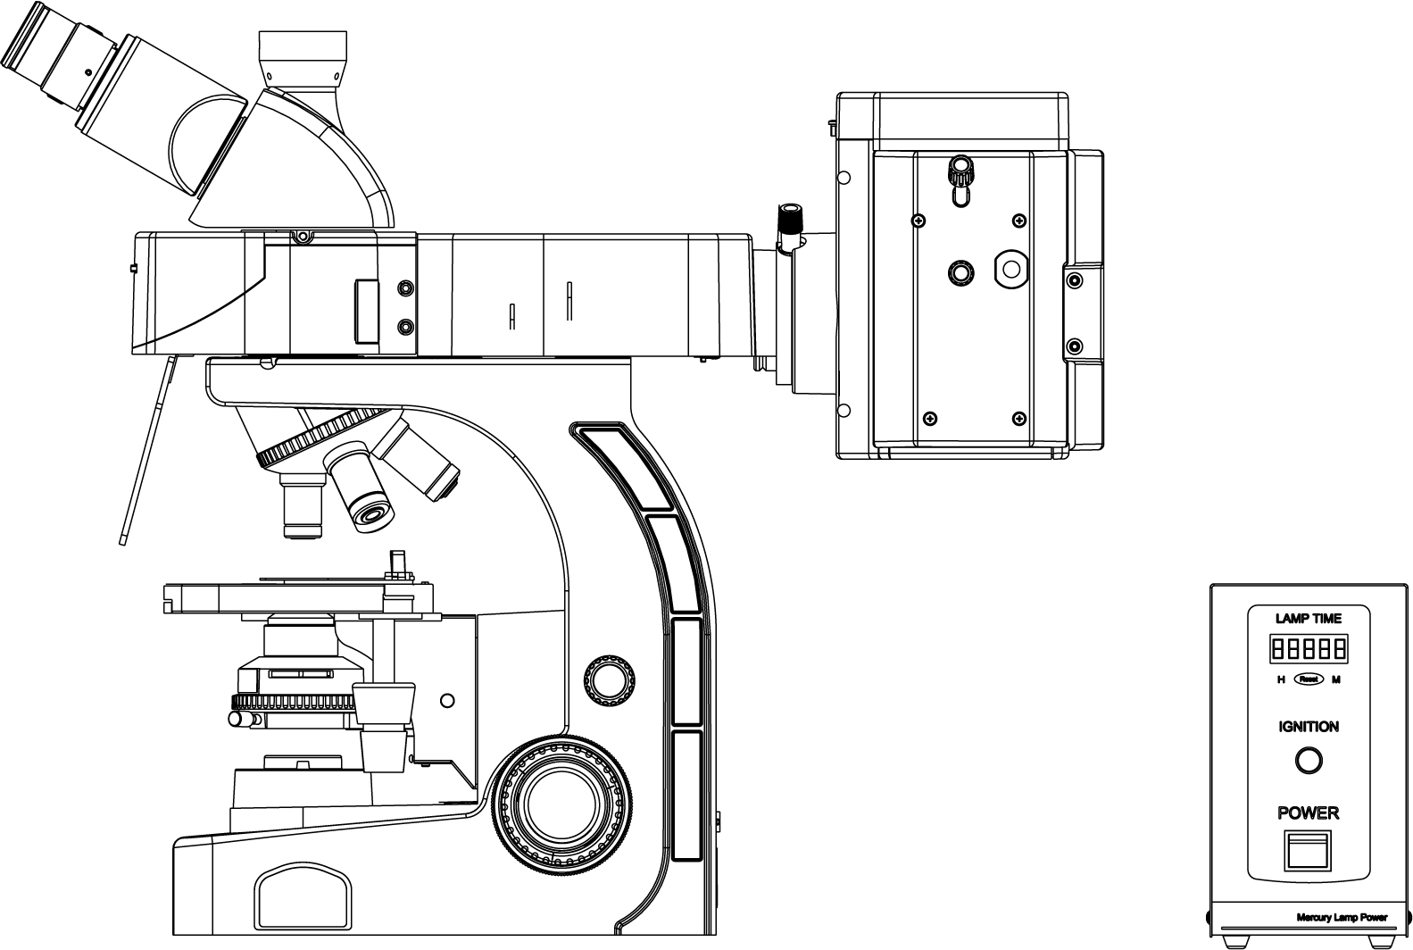

Operation Manual

Fluorescence Microscope

This Manual is for Fluorescence Microscope. To insure the safety, obtain optimum performance and to familiarize yourself fully with the use of the microscope, we recommend that you study this manual thoroughly before operating the microscope. Retain this instruction manual in an easily accessible place near the work desk for future reference.

GET READY
- Safety Precautions
- This equipment is just for the observation of fluorescence. Injury may occur or equipment will be damaged if this equipment is for other use.
- This equipment is provided with a simplified waterproof mechanism. Therefore, if culture liquid or water is split on /in the equipment, damage to the equipment or an electrical shock may result. Immediately set the main Switch to “O” (OFF) then disconnect the power cord from the wall outlet and wipe the liquid or water off if it is spilt on them.
- The microscope is not covered by warranty in terms of laser safety. The user should assume liabilities for any consequence of user modification.
- The surfaces of the lamp housing will become extremely hot during operation. Be sure to keep the flammable stuffs such as paper, alcohol, oil away from the lamp house to avoid fire.
- When using the microscope, route the power cord away from the lamp housing. Should the power cord come in contact with the hot lamp housing, the power cord could melt and cause electric shock.
- To avoid potential shock hazards and burns when replacing the light bulb, set the main Switch to “O” (OFF) then disconnect the power cord from the wall outlet in advance. Whenever you replace the bulb during use or right after use, allow the lamp housing and bulb to cool before touching.
- Electric shock warning: Remove of the cover of the fluorescence equipment makes the dangerous electric parts inside exposed. Any contact with these parts may cause shock or death. In event of maintenance, please apply to qualified professionals for help.
- Be sure the bulb of the same description is used as you replace the mercury bulb. Damage will occur if bulb of different description is replaced.
- Always be sure the power cord provided by the manufacturer. If the proper power cord is not used, product safety performance cannot be warranted.
- To avoid potential shock hazards when replacing the fuse, set the main switch to “O” (OFF) then disconnect the power cord from the wall outlet in advance.
- Always ensure that the grounding terminal of the microscope and that of the wall outlet are properly connected. If the equipment is not grounded, we can no longer warrant the electrical safety performance of the equipment.
- Never insert metallic objects into the air vents of the lamp house as this could result in electrical shock, personal injury and equipment damage.
- A microscope is a precision instrument. Handle it with care and avoid subjecting it to sudden or severe impact.
- Moving the Microscope
- When moving the equipment, be sure set the main switch to “O” (OFF) then disconnect the power cord from the wall outlet in advance.
- When moving the microscope for a long distance, it is also recommended to disconnect all cables from the equipment.
- When transporting it, also engage the adhesive tape lock mechanisms and package it sufficiently.
- Also be careful against slipping of hands during carrying.
- ★ Damage to the microscope will occur if you grasp it by other parts including the stage, coarse/fine adjustment knobs, the nosepieces, etc.
- Working Environments
- Indoor use.
- Ambient Temperature: 5℃to 40℃ (41℉to 104℉).
- Maximum relative humidity: 85% for temperatures up to 31℃ (93℉), 60% at 37℃ (99℉), to 50% relative humidity at 40℃ (104℉).
- Supply voltage fluctuations: ±10%.
- Pollution degree: 2 (In accordance with IEC60664).
- Electric Power Specifications
- Input: 100-240V～0.5A, 47-63Hz
- Output: 6V 3.4A
- Fuse: 3.15A, 250V, F ф5×20mm
- Halogen Bulb Socket: G4
1. Purpose
The fluorescence microscope is our contribution to you for your application in gene, biology, medicine, bioscience and clinical laboratory, from routine to research and clinic diagnose .It also be widely used in industry, agriculture, farming, criminal investigation, forensic identification, environmental engineering, preventive medicine and so on in the field of detection analysis.

2. The Mechanism of Fluorescence in Generated
UV, V, B, G excitation system transmittance characteristic curve:
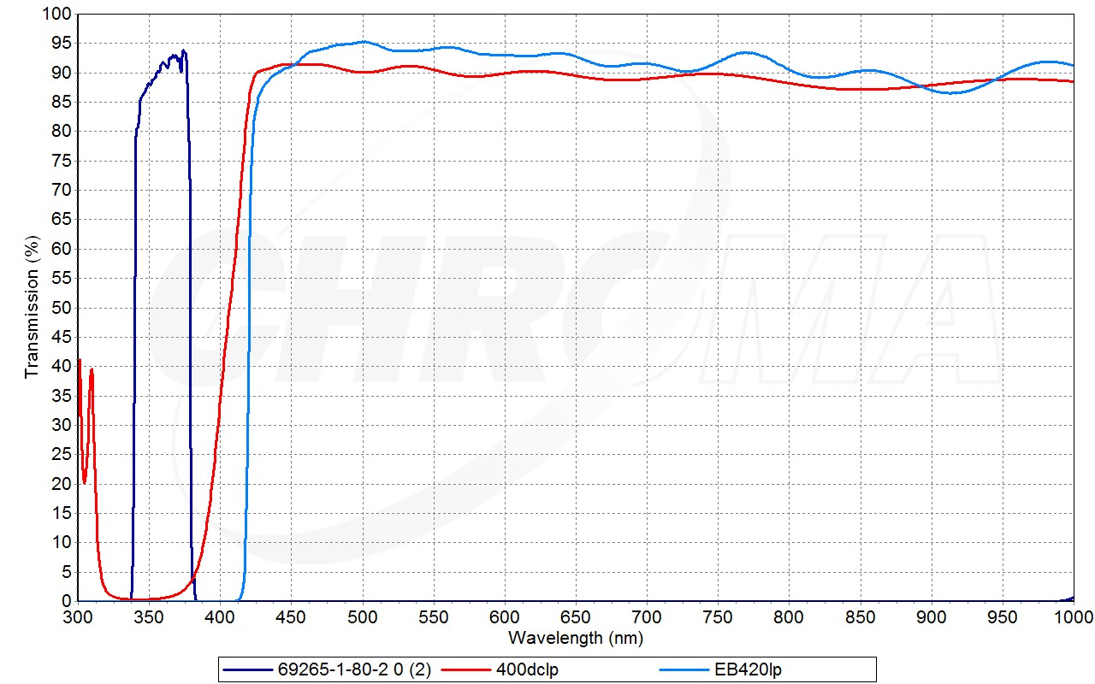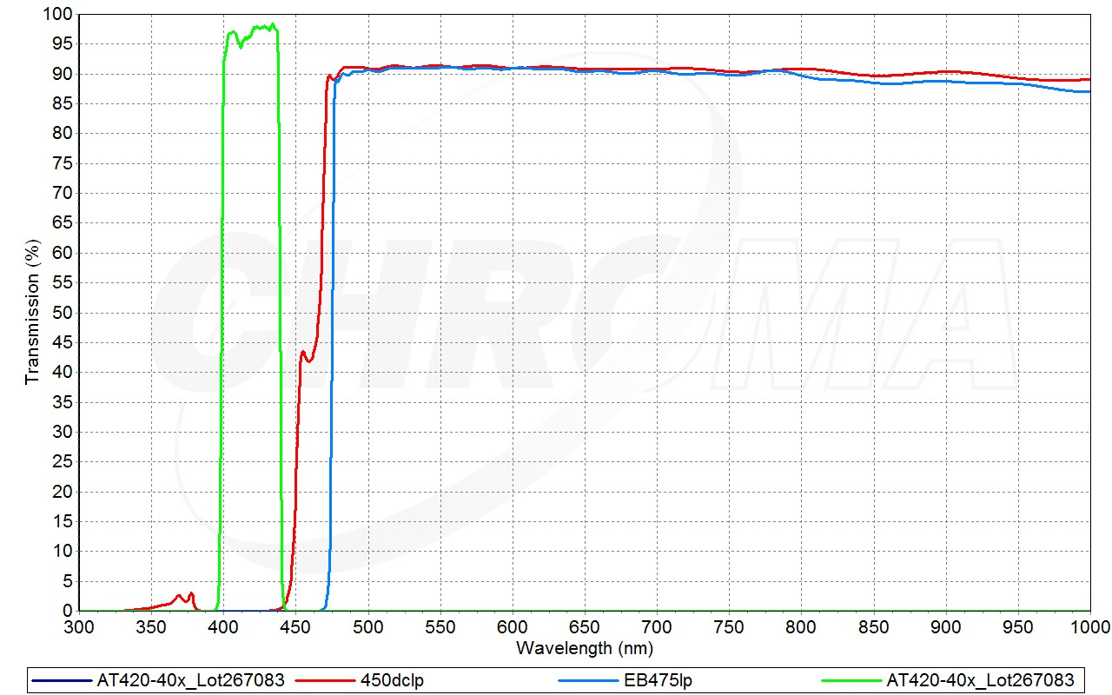
UV V
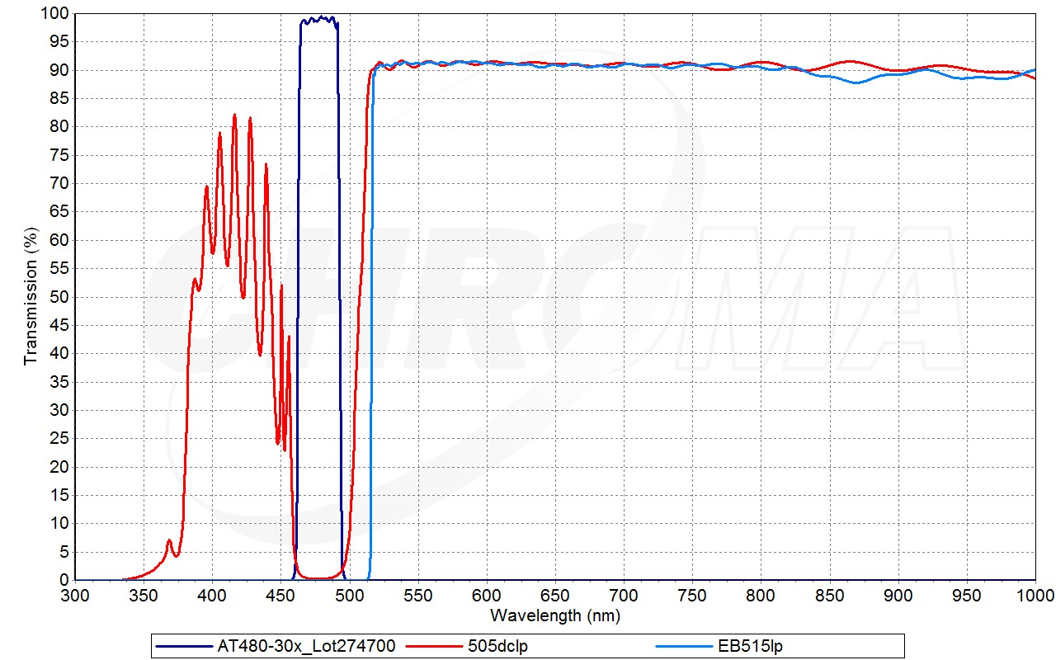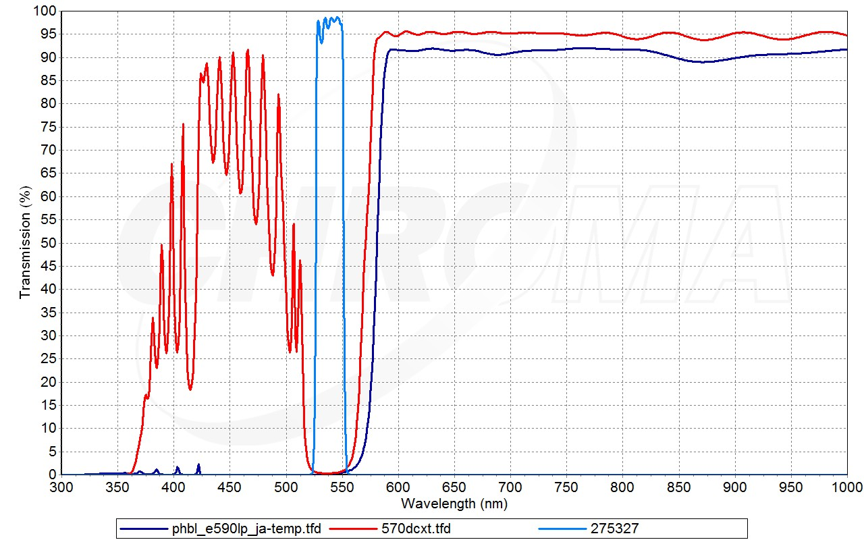
B G 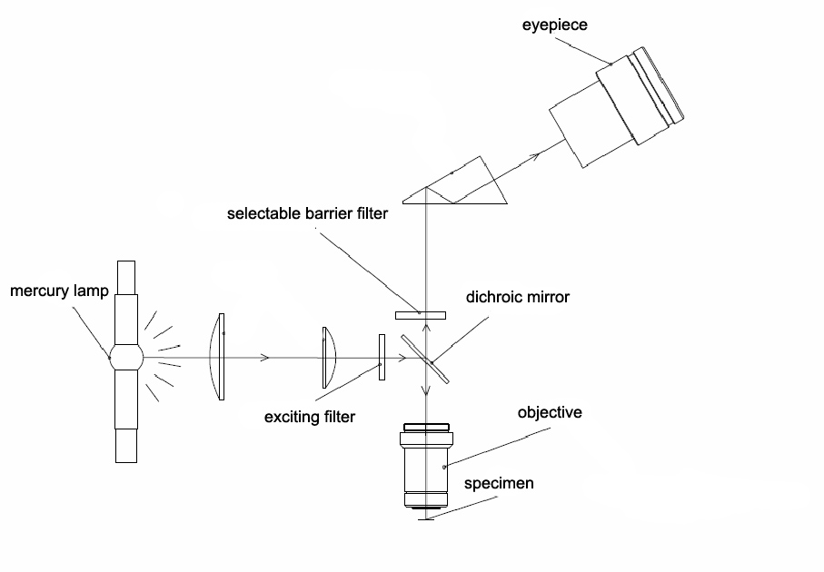
Fluorescence is a natural phenomenon of photoluminescence. Seaweed appears green under natural light, but when irradiated with ultraviolet light in a dark room it grows red. This is because the chlorophyll of the seaweed absorbs the ultraviolet light and converts its energy to light of longer wavelength, i.e. red. This phenomenon is known as luminescence, and the type of luminescence that stops immediately after excitation ceases, is referred to as fluorescence.
Reflected light fluorescence microscope: The specimen is illuminated from above, allowing most of the exciting light that is not absorbed by the specimen to pass through. Fluorescent light and some exciting light reflected by the glass surface enter the objective but the exciting light is again cut off by a barrier filter.
To illuminate the specimen from above, a half mirror is necessary. A standard half mirror reflects 50% of the exciting light and passes only 50% of the fluorescence, dropping the efficiency to a meager 25%.Therefore a mirror with a special coating, called a dichroic mirror, is employed.
A dichroic mirror reflects almost all (90%) of light with a wavelength shorter than a certain value, where as it allows most of the light with a wavelength longer than that value to pass. In other works, it allows exciting light to reach the specimen efficiently, and also passes most of the fluorescent light to the observer. As a result a dichroic mirror operates with more than 3 times the efficiency of a standard half mirror.
3. Module Nomenclature
This device includes reflected illumination device, DC 100W mercury lamp power box, DC 100W mercury lamp box, dichroic mirror, and the microscope mainframe.

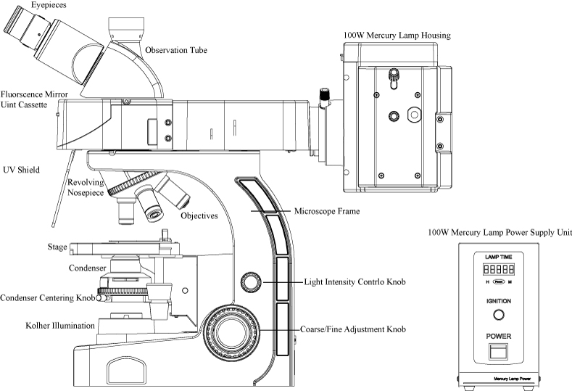
4. Fluorescence Observation Procedure
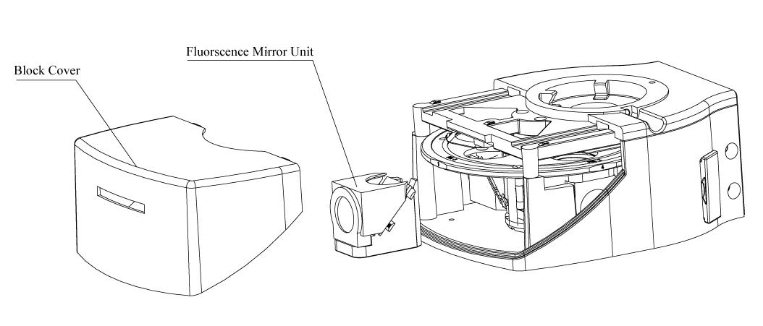
Adjust the microscope by the method of bright field observation, and then follow the procedures below to start fluorescence observation.
- Make sure the supply voltage is Conforming to the requirement, before you insert the mercury lamp plug to the socket.
- Turn on the mercury lamp，insure the fluctuation of mercury lamp power supply voltage is not to be more than 220v±10v.It may take more than 10 minutes to reach the maximum luminous efficiency.
- Engage a 10X objective in the light path. Place the specimen on the stage. Rotate the X-axis and Y-axis knob to move the specimen to a desired position.
- Rotate the fluorescence module turret to select the right dichroic mirror unit in the light path.
- Adjust the coarse/fine adjustment knob to make the image clear.
- Adjust the mercury lamp center.
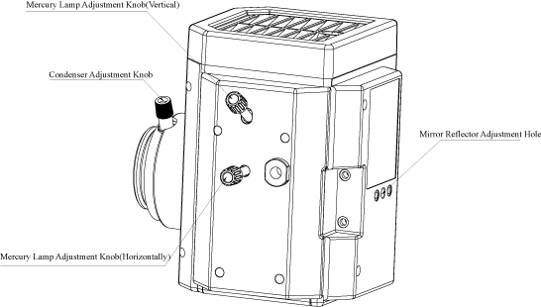
Rotating the condenser axial adjustment knob to make the light gathered together. Adjust the mercury lamp light box adjustment knob if the light is not at the center of the viewing field. Then rotate the condenser axial adjustment knob to make the viewing field brightly and equably.
Do not turn off the mercury lamp in the opening 15 minutes, because repeat switch will reduce the mercury lamp life. Block into the light barrier before you want to leave short time.
5. Mercury Lamp Power Box
- Significant Parameter
Input Voltage AC: 220V/110V±15%/50HZ
Output Voltage (Maximum): DC18V~40V
Output Current: 3.6A-4.9A
Starting Time: 2 Minutes
- Cautions
- Before you turn on the main switch, make sure the voltage is complying with the instrument’s requirement. The indicator light on the panel will be lighted, which indicates that the power is on, as well as the pointer of the voltmeter and current.
- The mercury lamp will be steady by 2minutes. The power dissipation of light tube is limited between 90W-135W.
- The useful life of mercury lamp is about 100 hours, so the illumination will be weaken after a period of time, then you can use the current adjust knob properly to increase the time of normal operation.
- After replace the mercury lamp, the calculagraph of power box must be clear. You can use the reset key to clear and re-time. The clear can be done in the condition of no power.
- Neither press the calculagraph reset key of power box in normal times, nor press it for a long time. Both of them will influence the useful life.
- Neither test the output voltage under the unload condition, nor open the power box to adjust or remodel, in order to avoid damaging mercury lamp or power box.
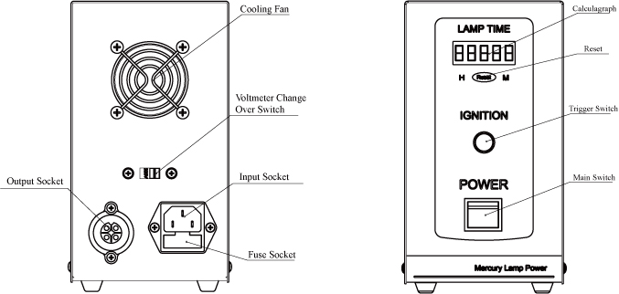

6. The Replacement of Fluorescence Mercury Lamp
Turn off the power of fluorescence, then loosen the screw of mercury lamp box, take the lamp holder out slantwise slowly, loosen two pinching screws of mercury lamp, take the old lamp off and change the new one, and then tighten the two pinching screws, put back the holder, tightening the screw of mercury lamp box. At last align the mercury lamp by the preceding way.
- Don’t take out the mercury lamp under the circumstances that the power is on. It’s very dangerous!
- Replace the mercury lamp after it cools down.
- Pay attention to the direction of mercury lamp’s anode and cathode, and rotate the glass shell to keep the asymmetrical part off the direction of collecting mirror.
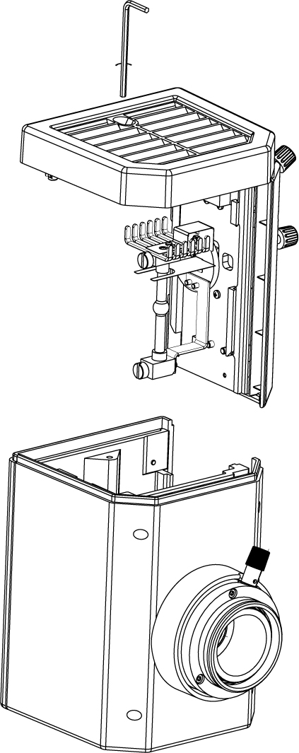
- Dip the gauze with a little mixture of alcohol and ether (4:6) to clean the glass shell. Don’t let dust or fingerprint to sully the lamp tube.

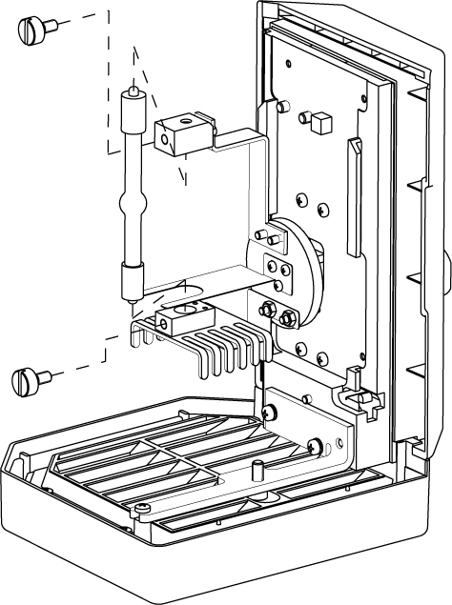

7. Maintenance
- Cleaning of the instrument
  - Don’t touch the surface of the exerted lens directly. You can use soft brush or gauze to remove dust, or clean it with absorbent cotton and the mixture of alcohol and ether (1:4).
  - Alcohol and ether are both inflammable, keep them away from fire. Be careful when switch the power to prevent a fire.
  - Don’t clear the painted surfaces and plating surfaces with organic solution such as alcohol, ethane or mixture, clean it with silk and soft detergents is suggested.
  - Plastic surface should be cleaned by a soft cloth dipped by clean water.
- Usage and storage environment
  - The instrument should be used or placed in an environment which is shady, dry, dustless, and shockproof, no acid/base steam or any other corrosive gas.
  - The normal running conditions of instrument: the interior temperature must between 0°C and 40°C; the maximum relative humidity is 85%.
  - In high humidity area, it’s suggested to install dehumidifier devices when you use the microscope to prevent optical element from mildewing or fogging.
  - Be careful when you use or handle the instrument to prevent from shocking or crashing. You should lift the instrument when you want to move it, don’t drag it on the worktable, so as not to damage the tabletop or instrument.
  - Turn off the power when the instrument is not working, put on the dust helmet and lays it in a dry and shady place.
In order to keep instrument’s performance index, regular inspection is suggested. When you find the instrument is out of action and need repair, please contact the manufacture factory or the handy dealer.

